Network Threats and Mitigation & Physical Security and Risk
Q1 Create a table listing 5 common network threats (such as phishing, DDoS, man-in-the-middle, malware, and password attacks), and for each, write one real-world example from an app or service you use (like WhatsApp, Instagram, or Paytm).
Ans:
Network Threat | Description | Real-World Example
Phishing | Fake emails or messages are used to steal usernames, passwords, or bank details. | A fake Paytm SMS asks you to click a link and enter your account details.
DDoS (Distributed Denial of Service) | Many computers send huge amounts of traffic to a server, making the website slow or unavailable. | Instagram becomes temporarily unavailable because of a DDoS attack.
Man-in-the-Middle (MITM) | An attacker secretly intercepts communication between the user and the server. | While using WhatsApp on an unsafe public Wi-Fi, someone tries to intercept your network traffic.
Malware | Harmful software that can steal data or damage a device. | Downloading a fake WhatsApp APK installs malware on your phone.
Password Attack | Attackers try to guess or steal passwords using different methods. | Someone repeatedly tries to log in to your Instagram account using common passwords.

Q2. Simulate a brute-force attack scenario by writing a simple Python script that tries to guess a 4-digit PIN code by checking all possible combinations against a preset value.<br><br><em><strong>Constraint:</strong> The script should print the number of attempts it took to guess the correct PIN.</em>
Ans:
Algorithm:
- Set a predefined 4-digit PIN.
- Initialize the attempt counter.
- Try all PIN combinations from 0000 to 9999.
- Compare each generated PIN with the correct PIN.
- If the PIN matches, display the PIN and the total number of attempts.
- Stop the program.

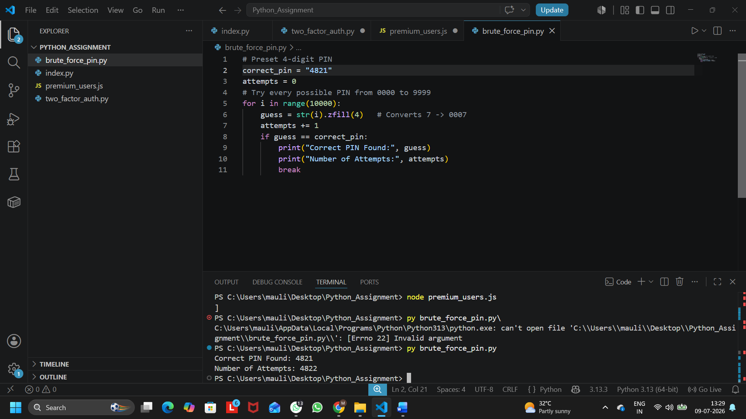
Figure 1: Output of Python Brute-Force PIN Guessing Program
Q3.List 4 physical security risks that could affect a server room hosting a popular app like Zomato or BookMyShow, and suggest one mitigation step for each risk.
Ans:
Physical Security Risks and Mitigation:
Physical Security Risk | Real-World Example | Mitigation (Prevention)
Fire | A fire in the server room can damage servers hosting Zomato or BookMyShow. | Install fire detection and automatic fire suppression systems.
Power Failure | A sudden power cut can shut down all servers. | Use a UPS and backup generator to provide continuous power.
Unauthorized Physical Access | An unknown person enters the server room and tampers with equipment. | Allow access only through ID cards, biometric authentication, or security guards.
Overheating | Poor cooling can cause servers to overheat and stop working. | Install air conditioning and continuously monitor the server room temperature.

Q4.Draw a simple floor plan (hand-drawn or digital) of a small office and mark at least 3 physical security measures you would implement to protect network equipment (such as CCTV, biometric access, or cable locks).
Ans:
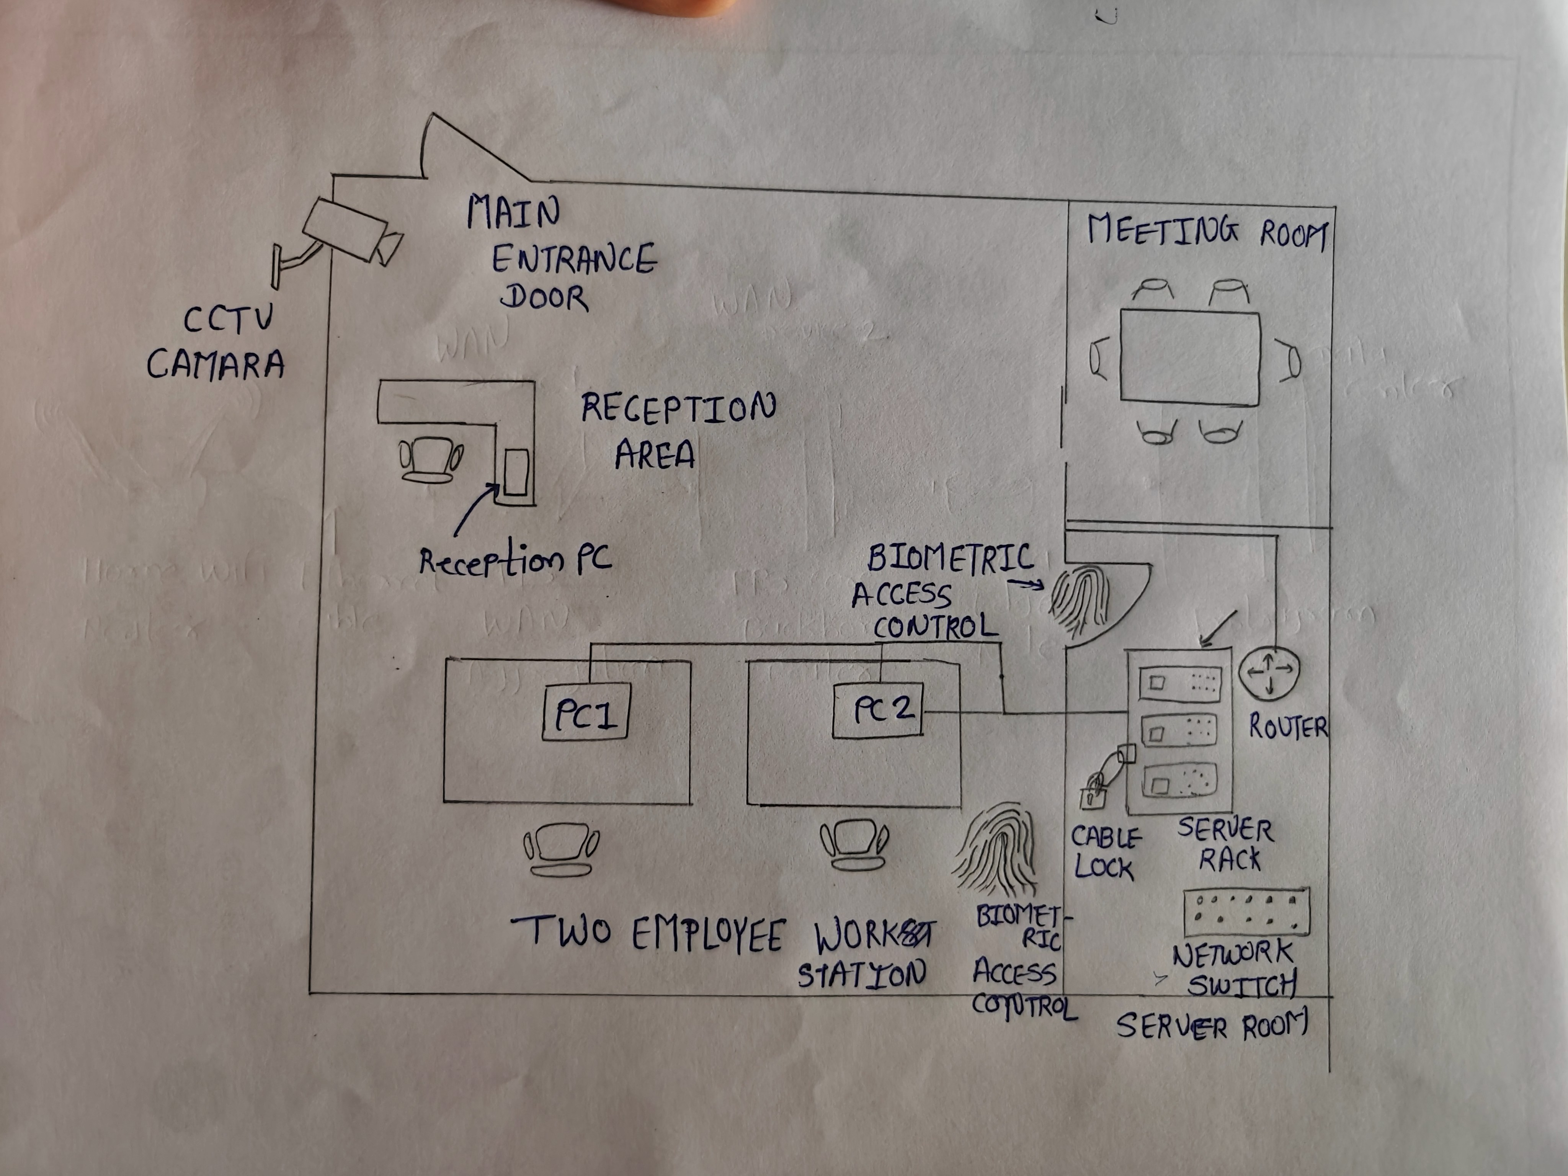
Figure 1: Office Floor Plan Showing Physical Security Measures for Network Equipment
Security Measures:
Security Measure | Purpose
CCTV Camera | Monitors all activities in the office and server room.
Biometric Access | Allows only authorized persons to enter the server room.
Cable Lock | Prevents theft or removal of network devices and cables.

Q5. Use ChatGPT or a similar AI tool to generate a checklist of 7 actions a network admin should take to mitigate risks from both network threats and physical security breaches, then review and edit the checklist to make it specific for a college computer lab environment.
Ans:
No. | Security Checklist | Purpose
1 | Use strong passwords and change them regularly. | Prevents unauthorized access to computers and network accounts.
2 | Install and regularly update antivirus software on all computers. | Protects systems from malware and viruses.
3 | Enable Windows Firewall on every computer. | Blocks unauthorized network connections and attacks.
4 | Restrict access to the server room using locks or biometric authentication. | Prevents unauthorized physical access to network equipment.
5 | Install CCTV cameras in the computer lab and near the server room. | Helps monitor activities and improves physical security.
6 | Keep all operating systems and software updated with the latest security patches. | Fixes known security vulnerabilities and improves protection.
7 | Regularly back up important files and maintain a UPS for power backup. | Prevents data loss during hardware failures or power outages.

